java:

<https://github.com/liuyubobobo/Play-with-Data-Structures>

python :

<https://github.com/nicemayi/play-with-data-structures>

go:

<https://github.com/donng/Play-with-Data-Structures>

C++:

<https://github.com/houpengfei88/Play-with-Data-Structures>

js:

<https://github.com/biaodigit/Play-with-Data-Structures>

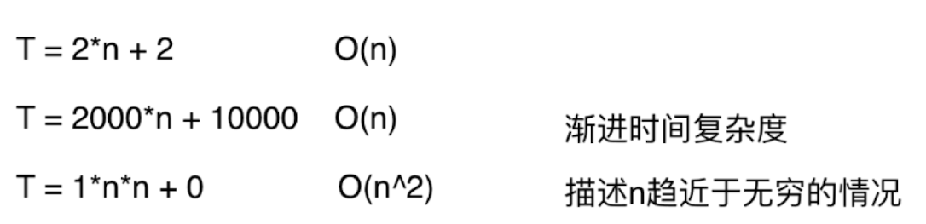

添加操作

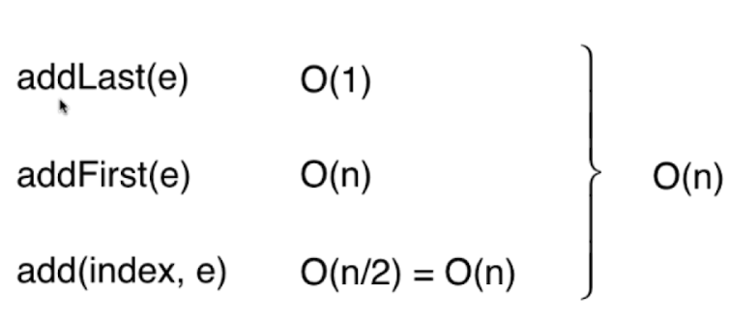

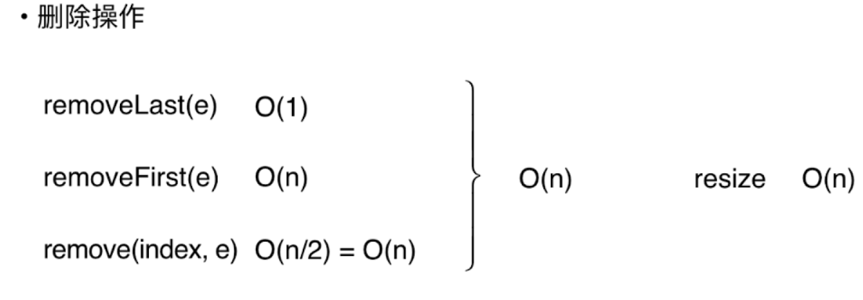

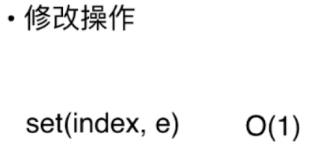

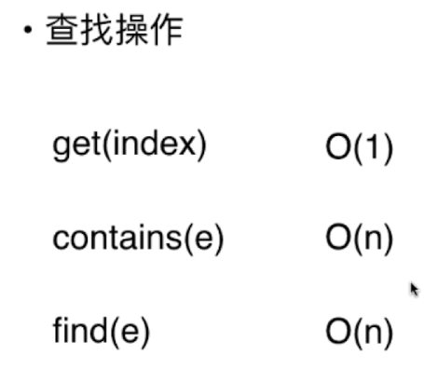

综合起来:

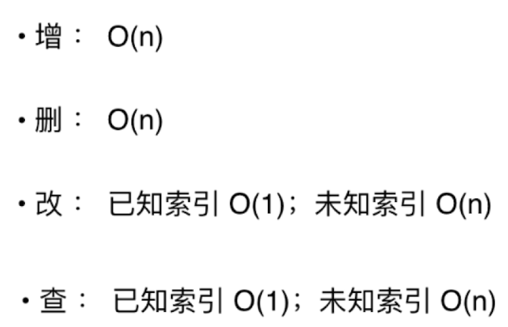

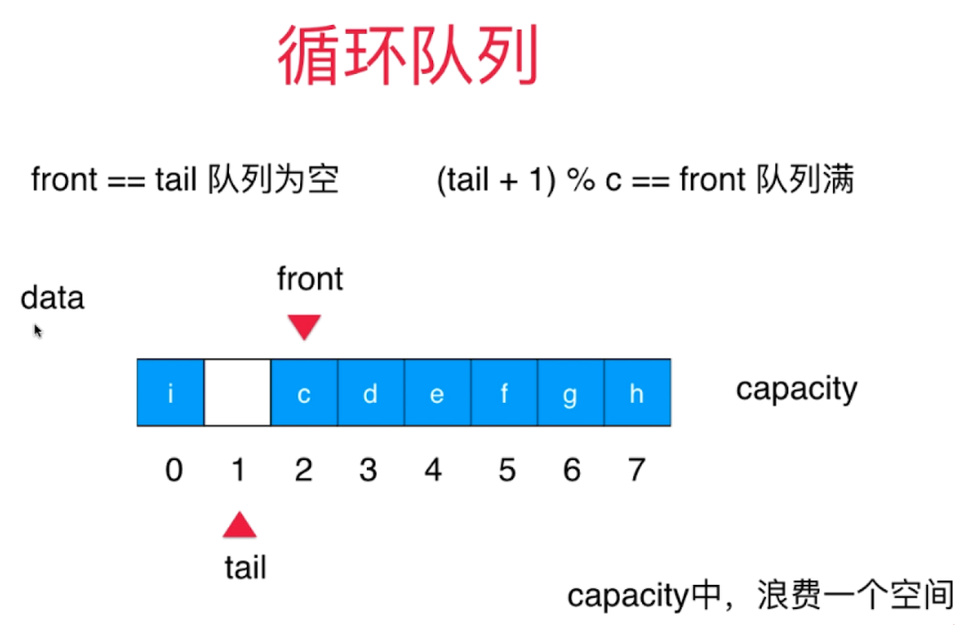

链表的特点:

